Arduino Lesson 2
Let them blink!
- Intro
LED experiment is a basic one，last lesson“ Hello World！”already used Arduino build-in LED，this time we use other I/O interface and external DIP LED.

- Connection
Besides Arduino and USB cable, we also need below parts.

Red 5mm DIP LED x 1
220ΩResistor x 1
Breadboard x 1
Jumper wires x 1 Bundle

Now We follow schematic diagram and physical figure below to connect parts.We use digital interface #10.A current-limit resistor MUST be used here in case the LED burn out.
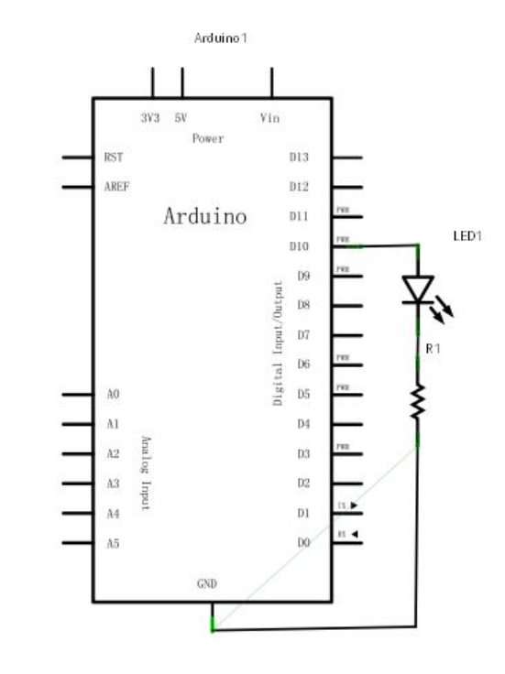
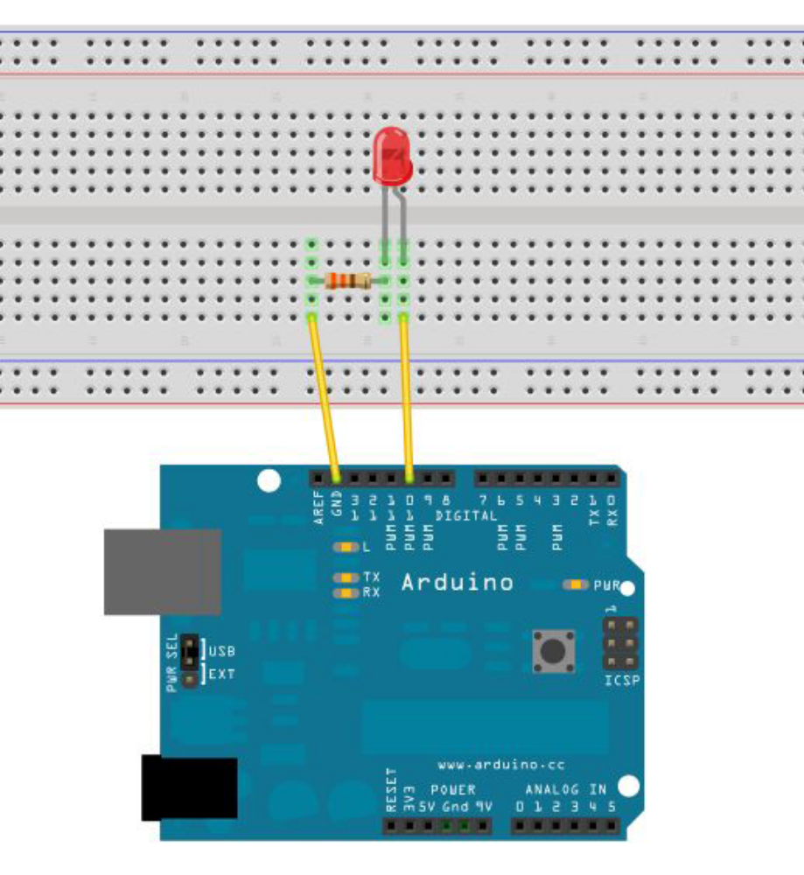
Now we start to program after all parts connected. First we make led
turn on for 1 sec.and turn off 1 sec. This is as simple as last one, just
switch the interface #13 to #10.
- Program for reference.
int ledPin = 10; //Define digital interface #10.
void setup()
{
pinMode(ledPin, OUTPUT);// Define led interface as output.
}
void loop()
{
digitalWrite(ledPin, HIGH); //Turn on the led.
delay(1000); //Delay 1 sec.
digitalWrite(ledPin, LOW); //Turn off the led.
delay(1000); // Delay 1 sec.
}
Download the program you will see the led flickering, so our small lights flashing experiment is done.

